**Muhammad Abdullah**

**SE(4A) | 19F-0916**

OS LAB

OS LAB 3 Shell Scripting

**TASK 1 (1st Part)**

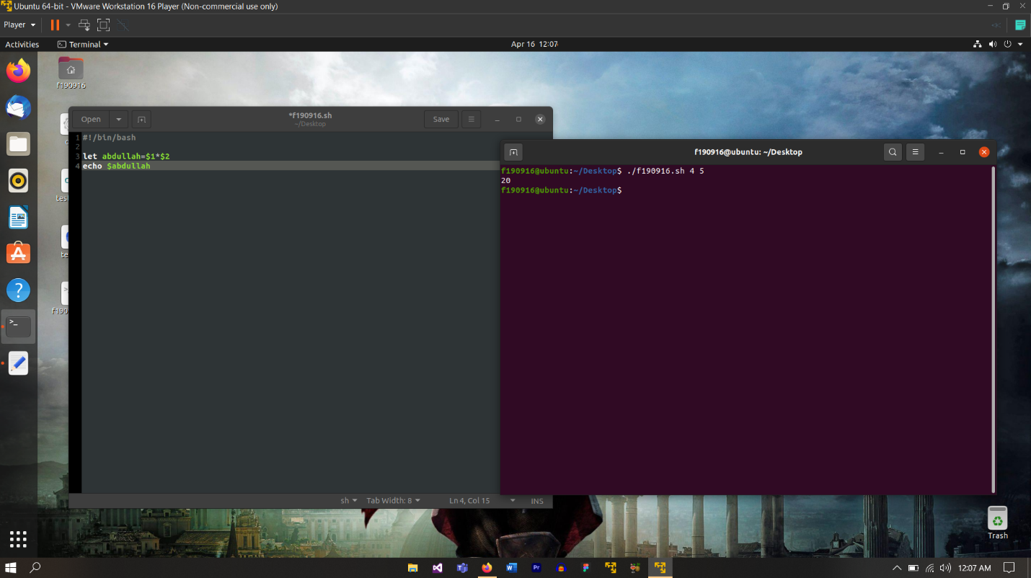

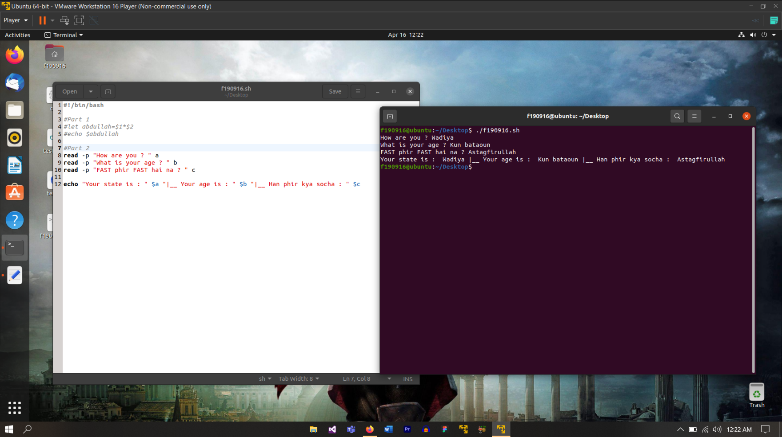

**TASK 1 (2nd Part)**

**TASK 1 (3rd Part)**

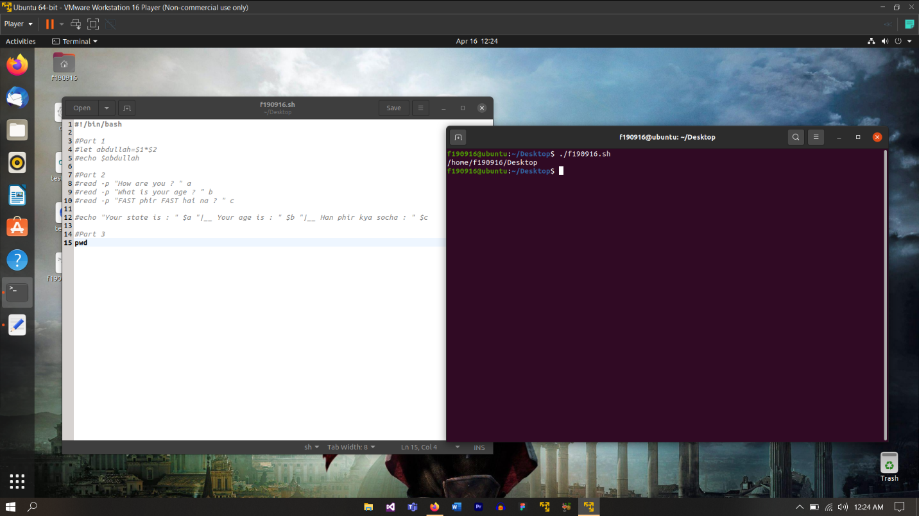

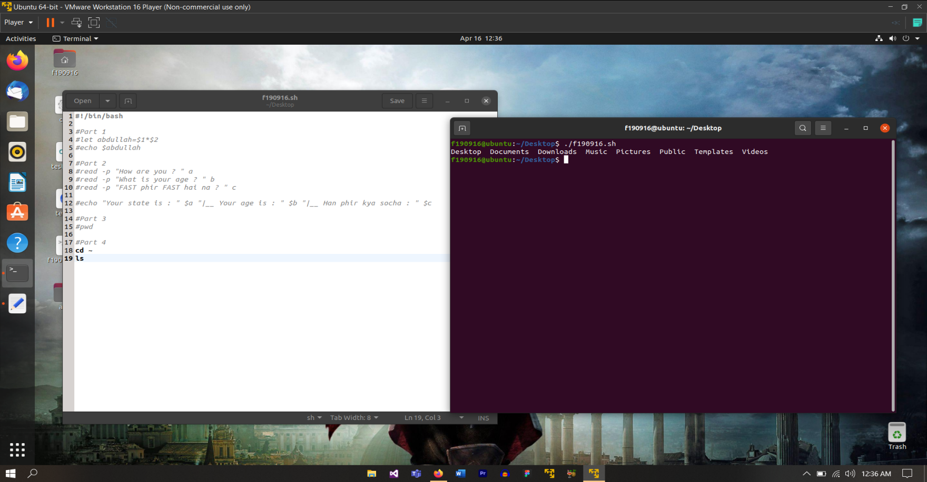

**TASK 1 (4th Part)**

**TASK 1 (5th Part)**

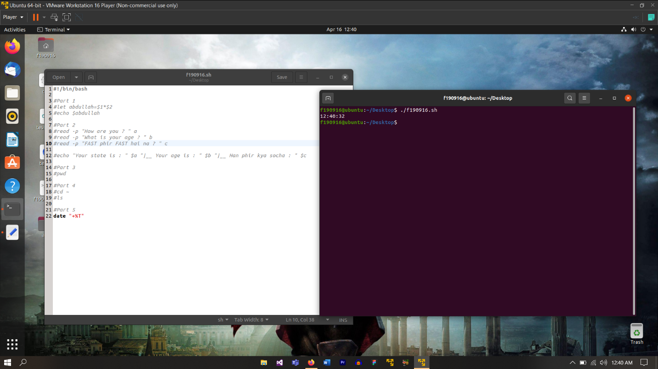

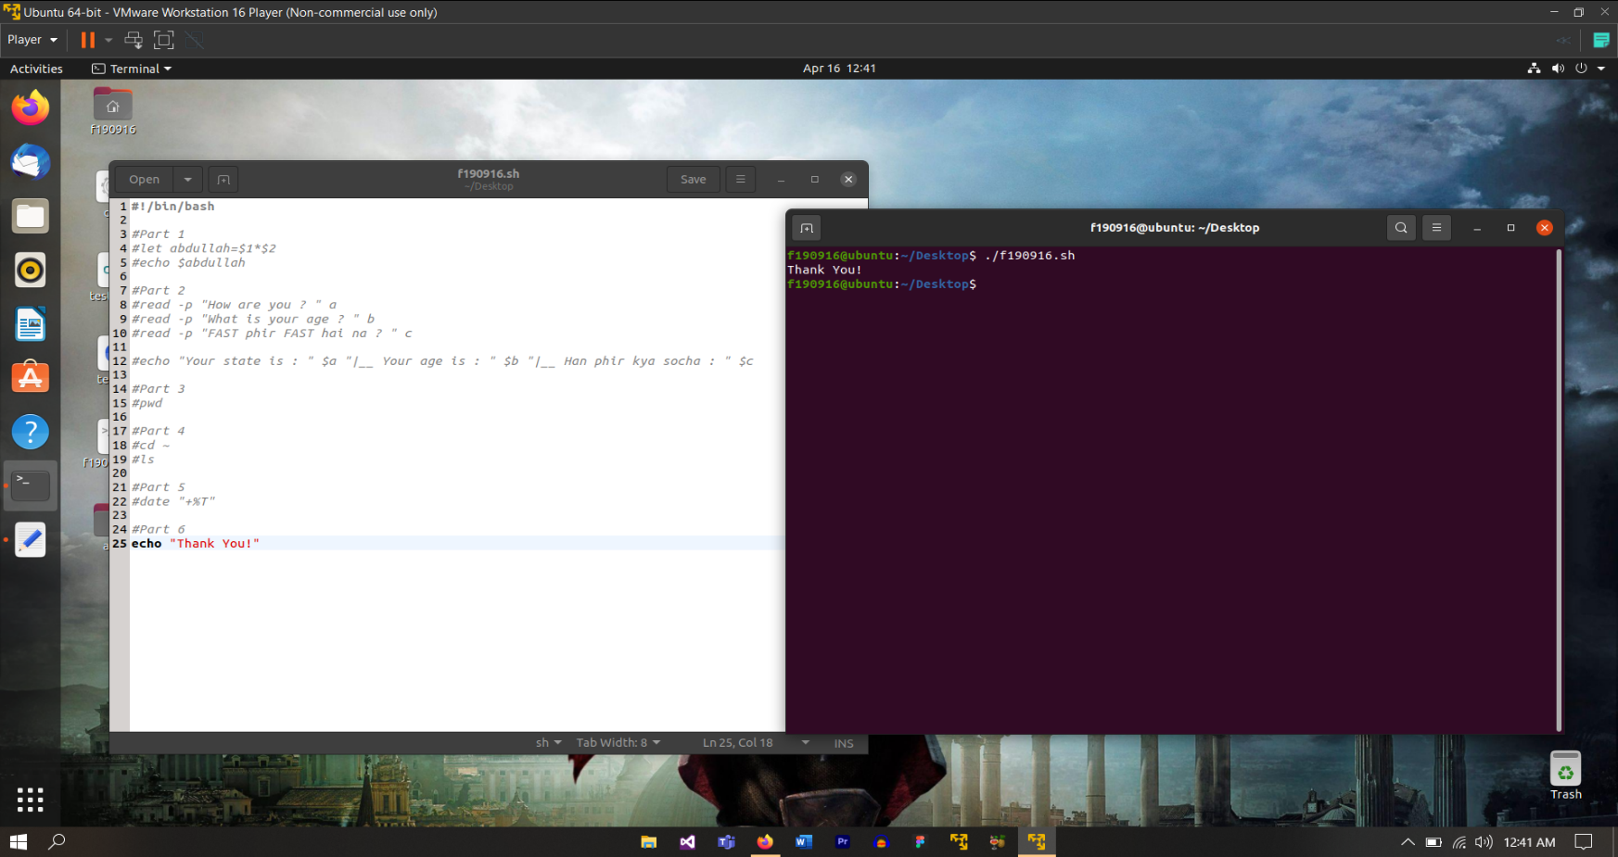

**TASK 1 (6th Part)**

**TASK 1 (FINAL)**

**This contains all the subparts of the Task 1 in a single execution state.**

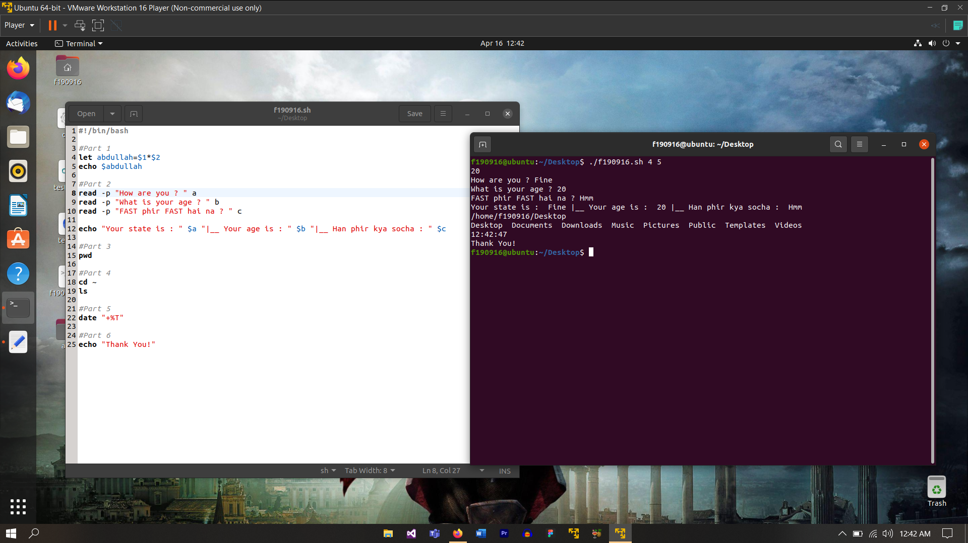

**TASK 2 (1st Part)**

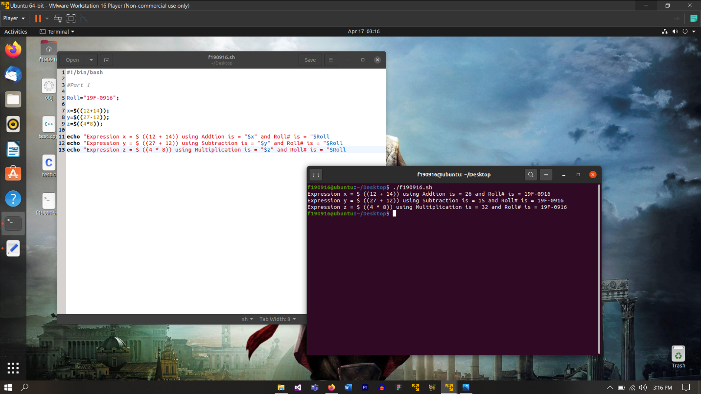

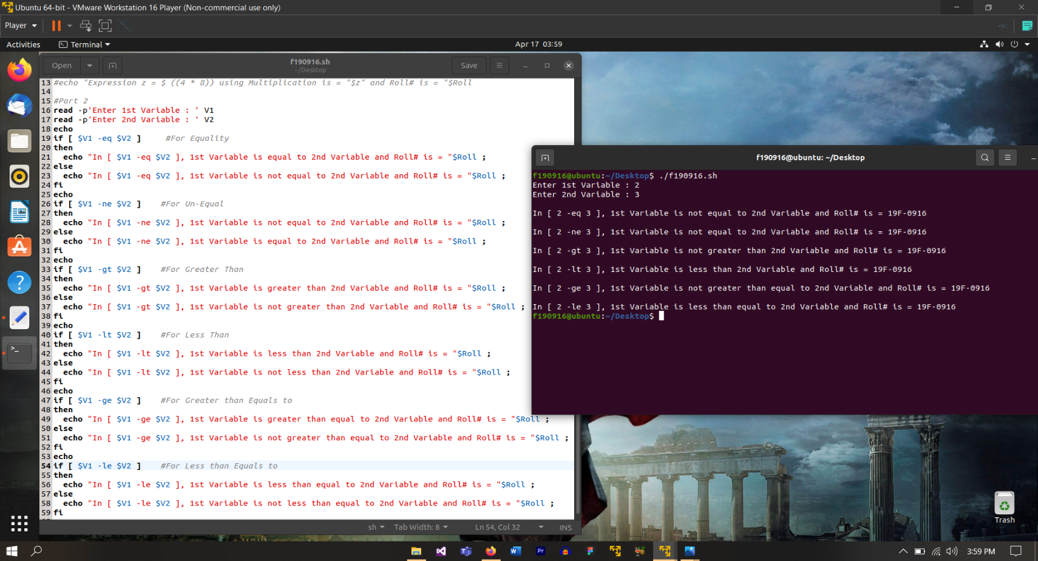

**TASK 2 (2nd Part)**

**TASK 2 (FINAL)**

**This contains all the subparts of the Task 2 in a single execution state.**

